Cognos Administrator.

Lab Material

Table of Contents

•Pre-requisites

•Installation

•Configuration

•CreatingEnvironmentVariables

•CreatingVirtualDirectories

•Create/Restore Sample Database

•AddingDataSources

•Deploying the Samples

•Set Permissions in Cognos Connections

Lab 01 - Pre Requisites

IIS should be installed and up. This could be ensured by typing http://localhoston browser

•Create a Schema for ‘Content Store’ in the data base (For example, Oralce is taken as database in this)

•Grant DBA privilege to the Content Store schema

•Ensure that the character set is UTF-8or UTF-16for the database created

•Run the issetup.exelocated at C8\C8_server\win32

Lab 02 - Installation

1. Keep the language selection default and click on Next

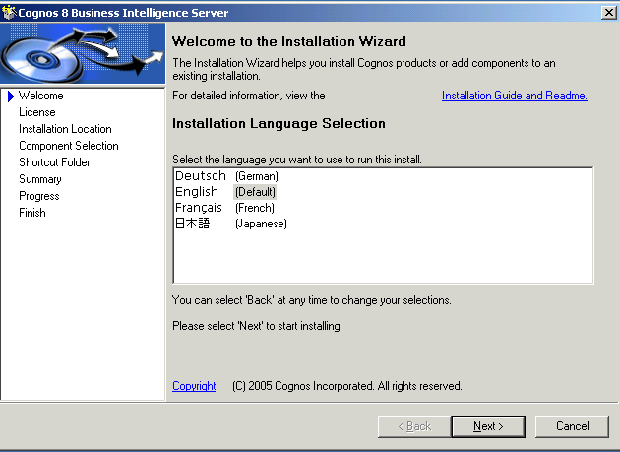

2. Select ‘I accept’ radio button and click on ‘Next’
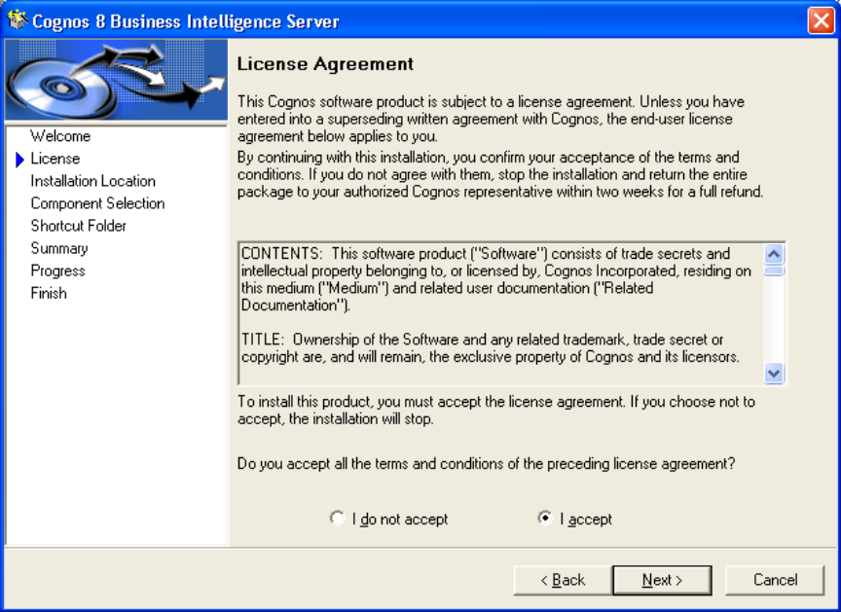

3. Select the Installation directory and click on ‘Next’

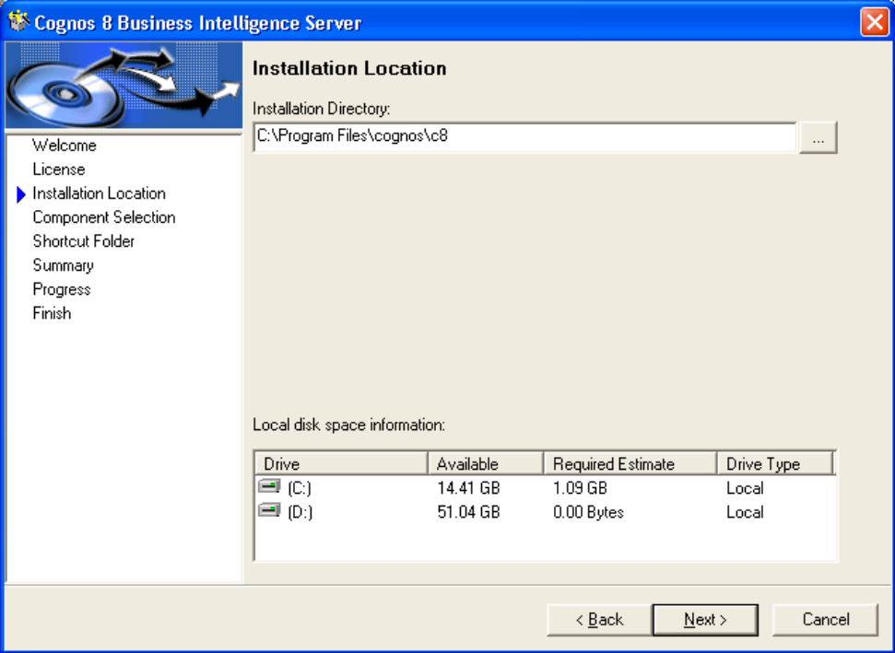

4. Make sure that all the components are ‘Green Ticked’ and click on ‘Next
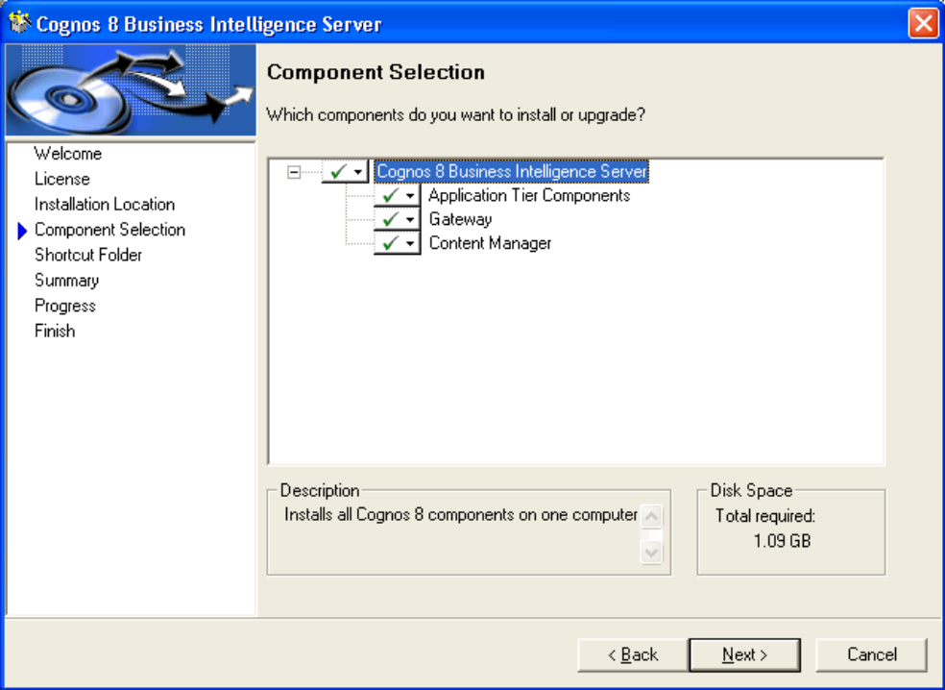

5. Leave the Shortcut Folder default and click on ‘Next’

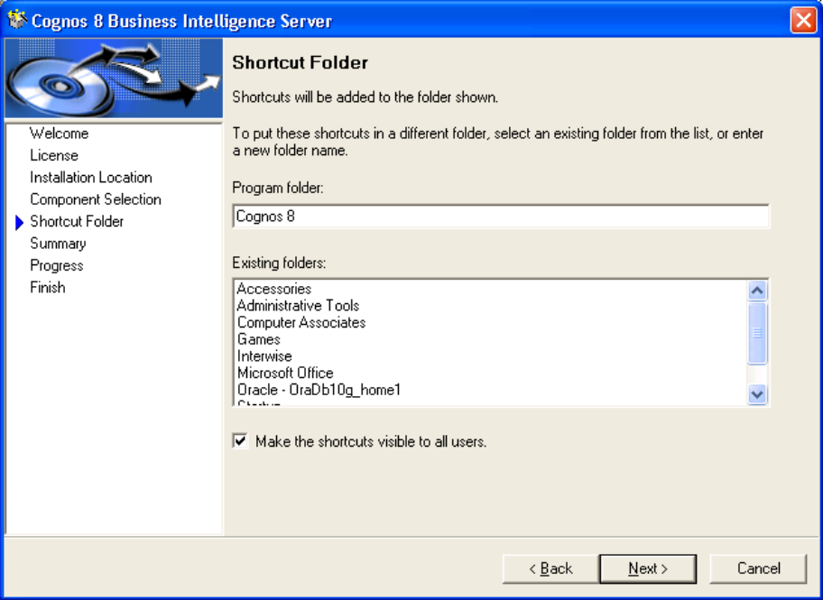

6. Review the Installation Summary and click on ‘Next’

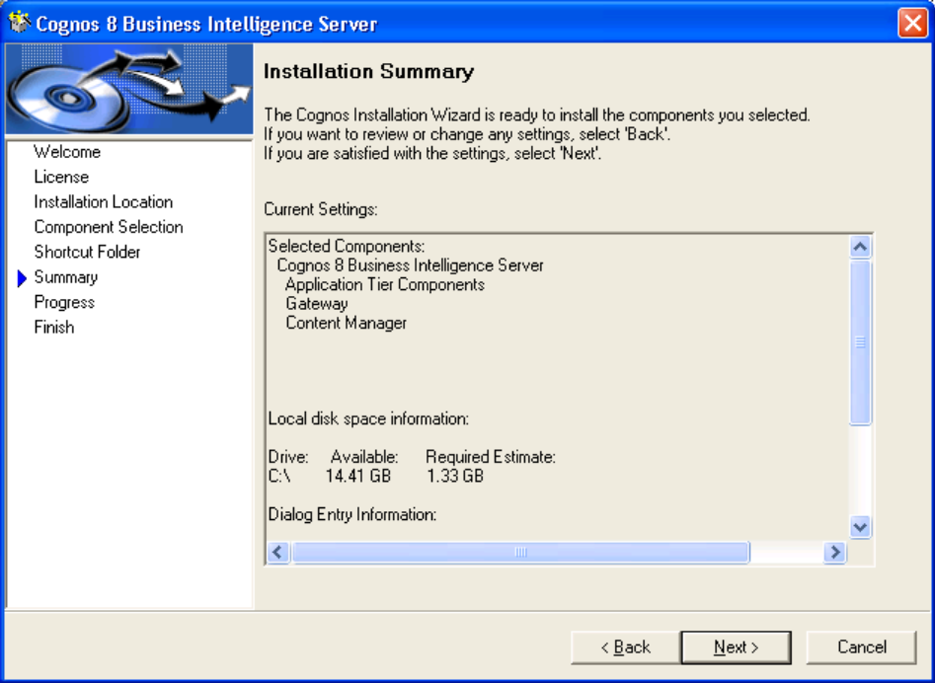

7. Let all the components get installed and then click on ‘Next’
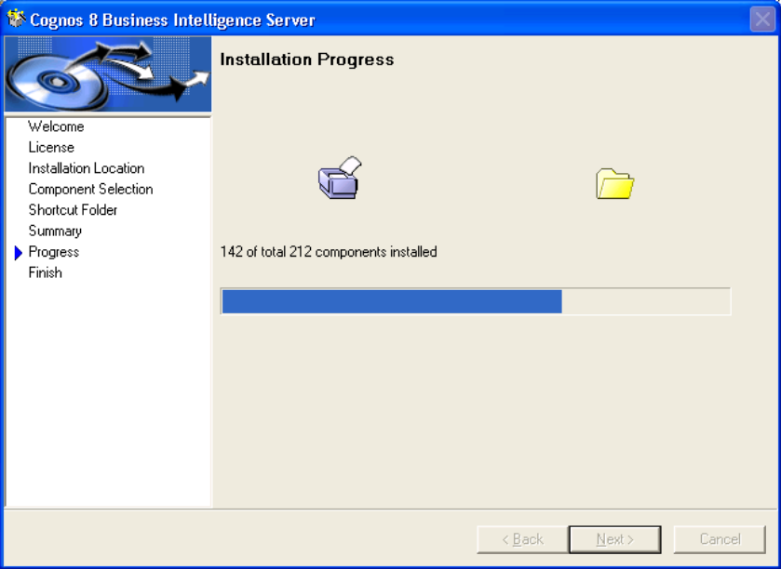

8. Check ‘Start Cognos Configuration’ and click on ‘Finish’ to start the configuration automatically

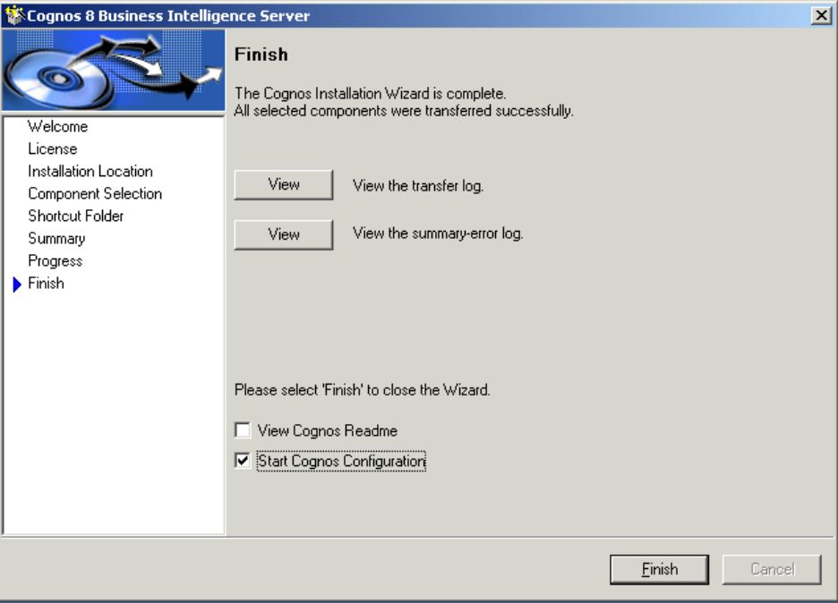

Configuration can be started manually by clicking on Program Files -> Cognos8 ->Cognos Configuration

Lab 03 - Configuration

Configure Security

Task 1. Configure the NTLM provider.

1. From the Start menu, point to All Programs, Cognos 8, and then click Cognos Configuration.

2. In the Explorer pane of Cognos Configuration, right-click Authentication, point to New resource, and then click Namespace.

3. In the New Namespace dialog box, under Name, type Local NT, and then from the drop-down list under Type, click NTLM.

4. Click OK.

The results appear as follows:
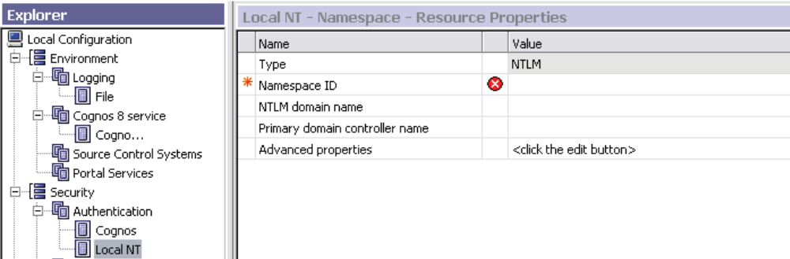

5. Click the cell in the Namespace ID row and the Value column, and type Local NT ID, and then press Enter.

6. In the Explorer pane under Authentication, click Cognos.

7. To the right of Allow anonymous access, click True in the Value column, and then click False to change the setting.

With Anonymous access now set to False, students will need to log in to Cognos Connection and provide a user name and password.

8. Leave Cognos Configuration open.

Create Users in Third-party Authentication Providers

Task 1. Create users in the NTLM authentication provider.

1. From the Start menu, click Control Panel, and then click Administrative Tools.
2. Click Computer Management.
3. Expand Local Users and Groups.
4. Right-click Users, and then click New User.
5. In the New User dialog box, in the User name box, type admin, and then in the Full name box, type Admin.
6. In the password and confirm password boxes, type Education1!.
7. Clear the User must change password at next logon check box, select the Password never expires check box, and then click Create.
8. Repeat steps 4 to 7 to create the following user:
User name: brettonf
Full name: Frank Bretton
Password: Education1!
9. Click Close to close the dialog box.
10. In the left pane, click Users to ensure that the users have been added.
11. Close Computer Management.
12. Close Control Panel.

Configure Content Store Data

Steps for Oracle
•If the data base is Oracle 10g
➢Copy the classes12.jar from oracle\product\10.2.0\db_1\jdbc\libfolder to c8\webapps\p2pd\WEB-INF\lib

•If the database is Oracle 9i
➢Copy the classes12.zip from oracle\product\10.2.0\db_1\jdbc\libfolder to c8\webapps\p2pd\WEB-INF\lib

- In the Explorer window, under Data Access, Content Manager, right-click Content Store and click Delete.
- Right-click Content Manager, and then click New resource, Database.
- In the Name box, type a name for the resource.
- In the Type box, select the type of database and click OK.
- Select the Type as ‘OralceDatabase’ from the drop down list
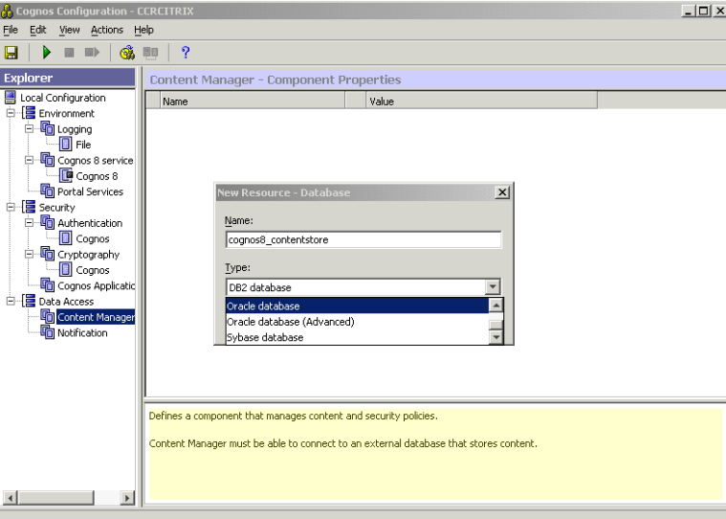

- Leave the database server and port number as default
- Under User ID and password give the schema details created for Content Store
- Give the Oracle host string under service name
- Test the connection between Content Manager and the content store.
Tip: From the Actions menu, click Test to test the connection between Content Manager and the content store.

Steps for SQL

•If the data base is SQL Server 2000
➢Service Pack 2 and Service Pack 3 is required for SQL Server 2000

- From the Start menu, point to All Programs, Microsoft SQL Server, and then click Enterprise Manager.
2. Expand Microsoft SQL Servers and SQL Server Group.
3. Expand <servername>, and then expand Databases.
4. Right–click Databases, and then click New Database. The Database Properties dialog box appears.
5. In the Name box, type cm.Note that “cm” stands for Content Manager.
6. In the Collation name list, select Latin1_General_CI_AS, and then click OK.
7. Leave Enterprise Manager open for the next step.
8. Test the connection between Content Manager and the content store.

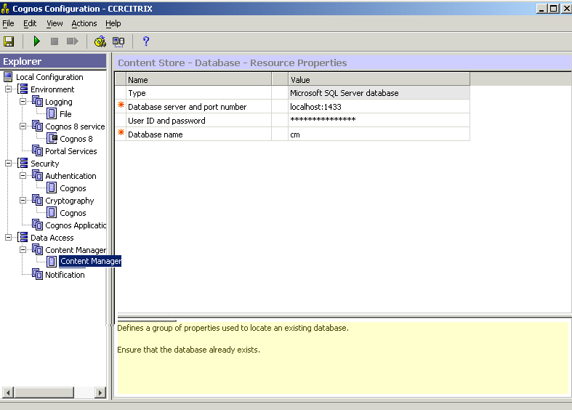

1. Click on the ‘Save’ icon to save the configuration settings
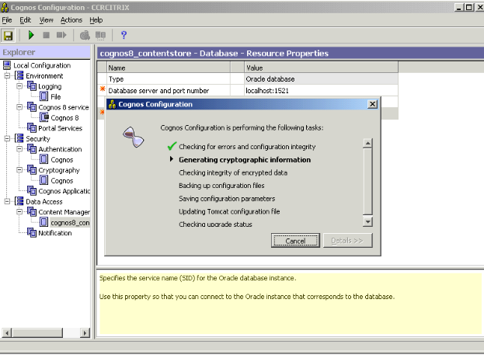
2. Make sure that all the components are Green Ticked as shown
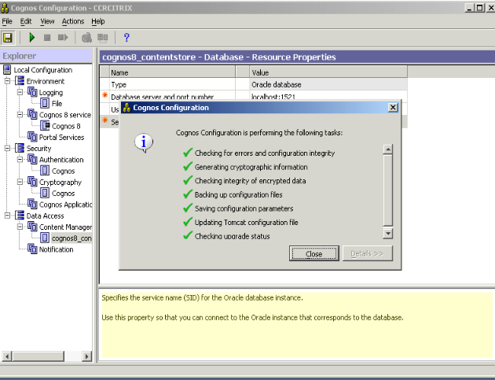
3. Click on the ‘Start’ icon to Run the Cognos 8 service
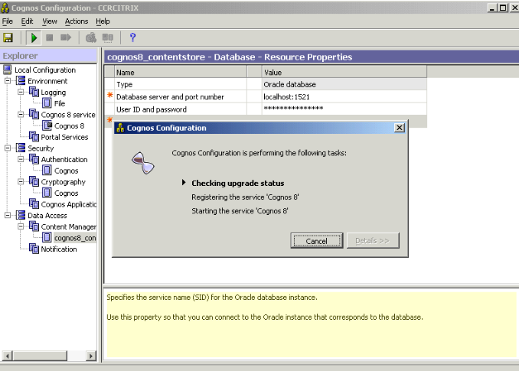

Lab 04 - Creating Environment Variable

Step

1. Right click on ‘My Computer’ and go to
My Computer->Properties->Advance->Environment Variables->System Variable->New

2. Create two Environment Variables with following properties

3. Make necessary changes to the path to match with installation location of Cognos8

Name | Path
JAVA_HOME | D:\Program Files\cognos\c8\bin\jre\1.3.1
CATALINA_HOME | D:\Program Files\cognos\c8\tomcat4.1.27

Restart the system for Environment Variables to take effect

Lab 05 - Creating Virtual Directory in IIS:-

•Right Click on ‘My Computer’ and go to ‘Manage’

•Towards the left side of Computer Management window, expand the Computer Management node to obtain Services and Applications node within it

•Go to Internet Information Services under it .There would be a Web sites folder in it

•Expand it to see the Default Web site.

Task 1. Set up alias for Cognos 8.

- Create the directories by right clicking on default website and say New->Virtual Directory

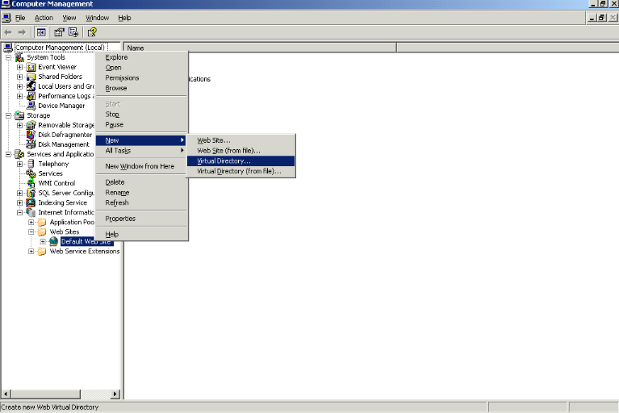

- Give the alias name as cognos8 and click ‘Next’

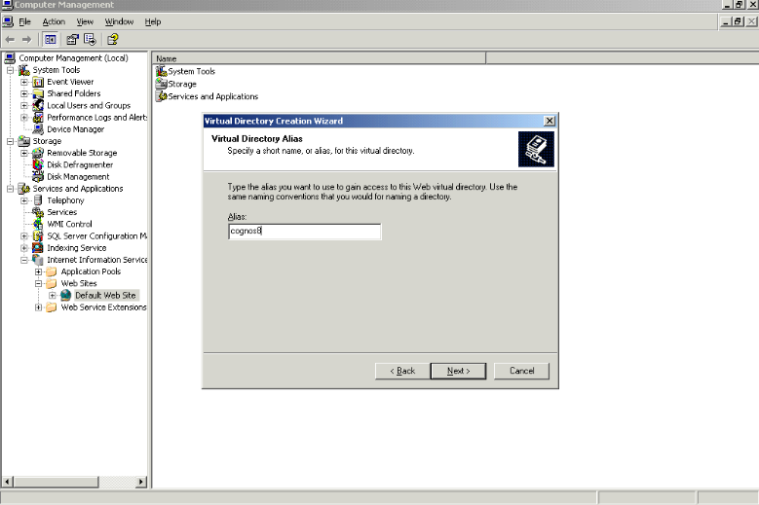

3. Give path as ‘D:\Program Files\cognos\c8\webcontent’ (As per Installation)
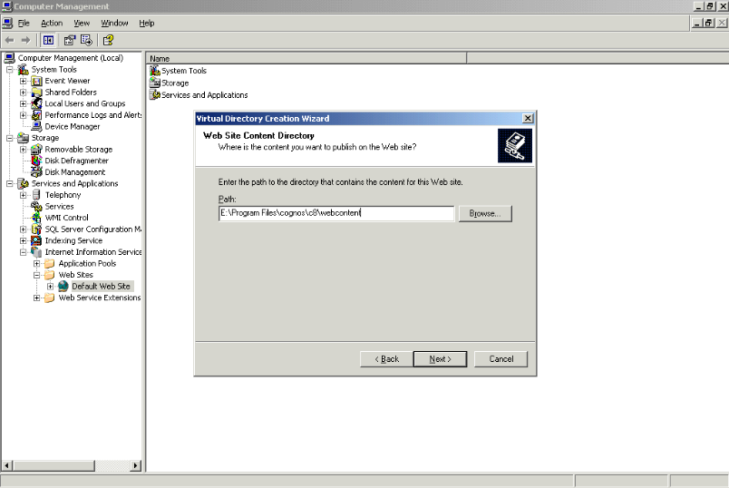

4. Assign Read, Run scripts, Write and Browse permissions and then click Next.
5. Click Finish.

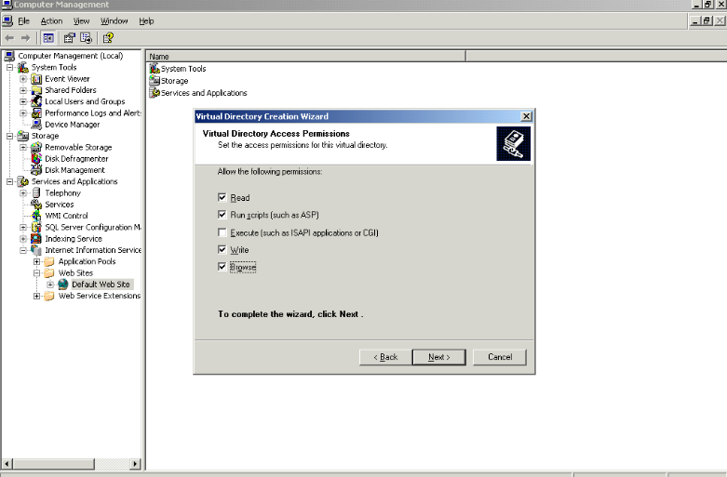

Task 2. Set up virtual directory for cgi-bin.

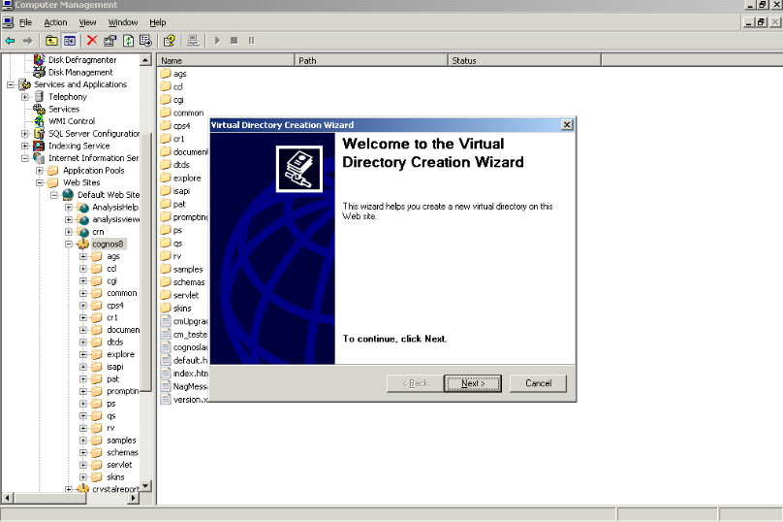

1. Create a new Virtual directory under ‘cognos8’ directory by right clicking on it and selecting new virtual directory and give the name as ‘cgi-bin’.

2. For cgi-bin, give the path as D:\Program Files\cognos\c8\cgi-bin

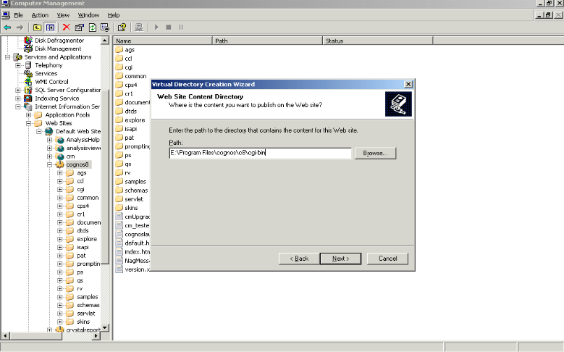

3. Go to properties of ‘Default Web Site’ and make changes as follows in the Home directory tab…
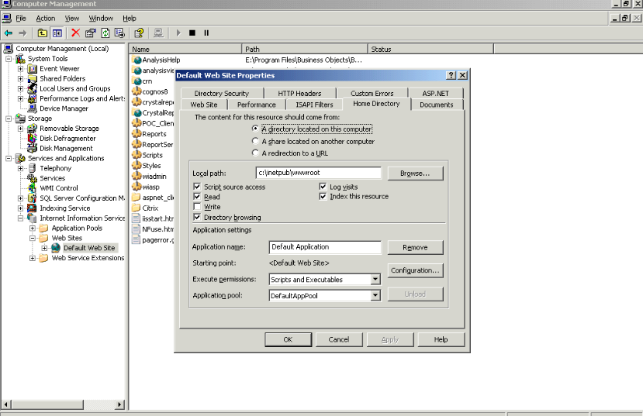
4. Check the following

•Script source access
•Read
•Directory browsing
•Log visits
•Index this resource
Change the following
•Execute permissions as Scripts and Executables

Make the same changes to ‘Web Sites’ Directory

Accessing Cognos8

Type the URL http://<machine name>/cognos8

User Name :- admin
Password :- Education1

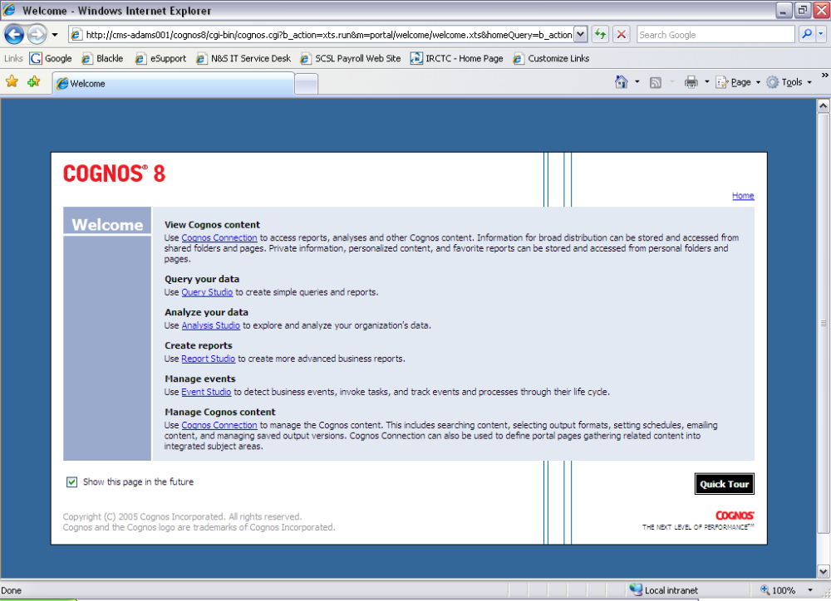

Lab 06 - Restore the Sample Databases

For SQL Server

Task 1. Add the databases.
1. While still in Microsoft SQL Server Enterprise Manager, right-click Databases, and then click New Database.
2. In the Name box, type GOSL, and then click OK.
3. Repeat steps 1 and 2 to add two new databases called GORT, and GOSLDW.

Task 2. Restore the databases.
1. Right–click the GORT database, point to All Tasks, and then click Restore Database.
2. In the Restore database dialog box, click From device.
3. Under Parameters, click Select Devices.
4. In the Choose Restore Devices dialog box, click Add.
5. In the Choose Restore Destination dialog box under File name, click the Ellipsis and browse to <Cognos 8 install location>:\Program Files\cognos\c8\webcontent\samples\datasources\sqlserver \GORT, and then click OK.
6. Click OK, and then click OK again.
7. In the Restore Database dialog box, click the Options tab.
8. Select the Force restore over existing database check box.
9. In the Restore database files as pane, ensure the Restore as path for both files in the Move to physical file name column points to the location of the GORT database.
If you chose the default location when you created the database, the path should read, <SQL Sever location>\MSSQL\Data\GORT.mdf for the first file, and <SQL Severlocation>\MSSQL\Data\GORT_log.ldf for the second file.
Please note: The GORT.mdf file may be called GORT_Data.mdf.
The result should appear similar to the one shown below:

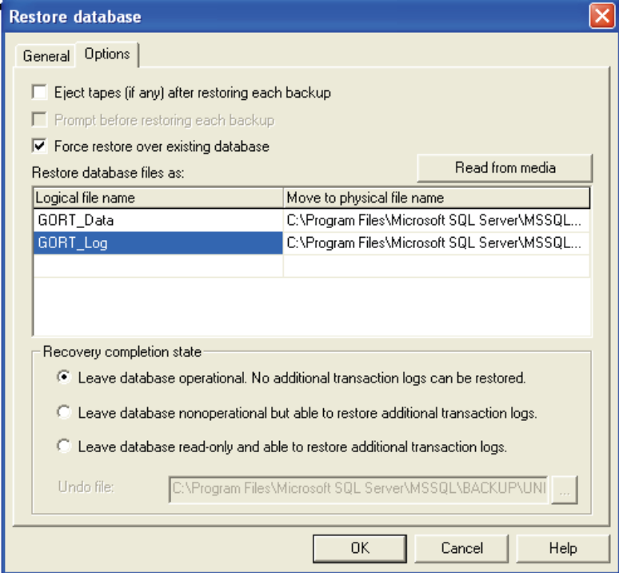

In the screen capture, the data file is listed first in the logical file name column, followed by the log file. If the positions are reversed (in other words, if the log file is listed first), ensure that each logical file name points to the correct physical file location.
10. Click OK. A message appears saying the restoration was successful.
11. Click OK to close the message.
12. Repeat Task 2 to restore the databases for GOSLDW and GOSL, ensuring the logical files are pointing to the GOSLDW and GOSL databases.
13. Close SQL Server Enterprise Manager.

For Oracle

Create schemas namely GOSL, GORT, GOSLDW, GOHR and GOMR in Oracle
1. SQL>CREATE USER GOSLIDENTIFIED BY GOSL
DEFAULT TABLESPACE USERS
TEMPORARY TABLESPACE TEMP;

2. SQL>GRANT CONNECT, RESOURCE, DBA TO GOSL

3. Repeat the same commands to create GORT, GOSLDW, GOHR and GOMR schemas

4. This should be done is ‘System’ schema of the database

Task 2:- Importing Sample in Oracle
1. Create a new directory named C8_Datasources at E:\

2. Copy GOSL.DMP, GORT.DMP, GOSLDW.DMP, GOHR.DMP, GOMR.DMP from
E:\Program Files\cognos\c8\webcontent\samples\datasources\oracle
to E:\C8_Datasources

3. Use the command
Imp system/<pass> file=<path> from user=<schema> touser=<user> ignore=y log=<name.log>

Example
imp system/manager file=E:\C8_Datasources\gosl.dmpfromuser=gosl touser=gosl ignore=y log=E:\C8_Datasources\gosl.log ( No. of Tables 19)

In the above example, ‘manager’ is considered as password for ‘system’ schema

4. Run the following commands to import into schemas GORT, GOSLDW, GOHR and GOMR also

imp system/manager file=E:\C8_Datasources\gort.dmpfromuser=gort touser=gort ignore=y log=E:\C8_Datasources\gort.log ( No. of Tables 10)

imp system/manager file=E:\C8_Datasources\gosldw.dmpfromuser=gosl dwtouser=gosldw ignore=y log=E:\C8_Datasources\gosldw.log ( No. of Tables 57)

imp system/manager file=E:\C8_Datasources\gohr.dmpfromuser=gohr touser=gohr ignore=y log=E:\C8_Datasources\gohr.log ( No. of Tables 11)

imp system/manager file=E:\C8_Datasources\gomr.dmpfromuser=gomr touser=gomr ignore=y log=E:\C8_Datasources\gomr.log ( No. of Tables 6)

Lab 07 - Add Data Sources in SQL
Task 1. Create data sources.
1. In Cognos Connection, from the Tools menu, click Directory.
2. On the Directory page, click the Data Sources tab.
3. Click New Data Source .
4. Under Name, type gosales, and then click Next.
5. Under Type, select Microsoft SQL Server (OLE DB), and then click Next.
6. In the Server name box, type localhost, and then under Database name, type GOSL.
7. Under Signon, select the Password check box.

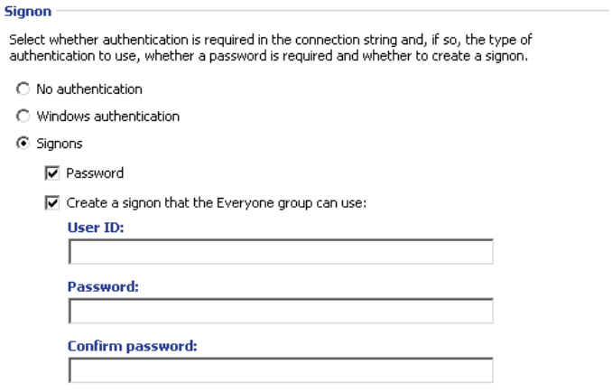

8. In the User ID box, type sa, and in the Password and Confirm password boxes, type Education1!, and then click Finish.
9. Repeat steps 3 to 8 to create the following data sources:
a. Data source name = go_data_warehouse, Database name = GOSLDW
b. Data source name = goretailers, Database name = GORT

Task 2. Create cube data source.
1. Click New Data Source .
2. Under Name, type Great_Outdoors_Company, and then click Next.
3. Under Type, select Cognos PowerCube, and then click Next.
4. In the Windows location box, type the following
<Cognos 8 installlocation>:\Program Files\cognos\c8\webcontent\samples\datasources\cubes\PowerCubes\En
\Great_Outdoors_Company.mdc
5. Under Testing, click Test the connection, and then click Test.
If the test failed, ensure that you typed everything correctly in step 4 and repeat testing your connection.
6. Click Close, and then click Close again.
7. Click Finish.
8. Click Return.
9. Leave Cognos Connection open for the next task.

Lab 08 - Deploy Cognos 8 Samples

Task 1. Prepare for deployment.
1. Start Windows Explorer.
2. Navigate to <Cognos 8 install location>:\ProgramFiles\cognos\c8\webcontent\samples\content.
3. Copy the Cognos_Samples.zip file and Cognos_PowerCube.zip.
4. Navigate to <Cognos 8 install location>:\ProgramFiles\cognos\c8\deployment, and then paste the zip files.

Task 2. Import the samples.
1. Open your browser, and then in the Address box, type http://localhost/cognos8, and press Enter.
3. From the Cognos 8 welcome screen, click Cognos Connection.
4. From the Tools menu, click Content Administration.
5. On the toolbar, click New Import.
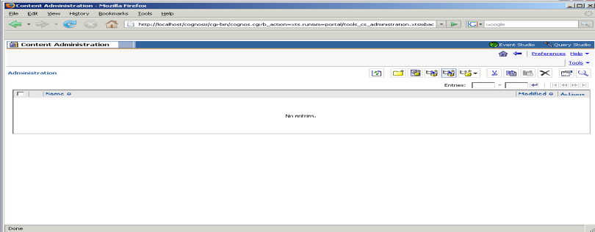
6. On the Select a deployment archive page, ensure the Cognos_Samples archive is selected, and then click Next.
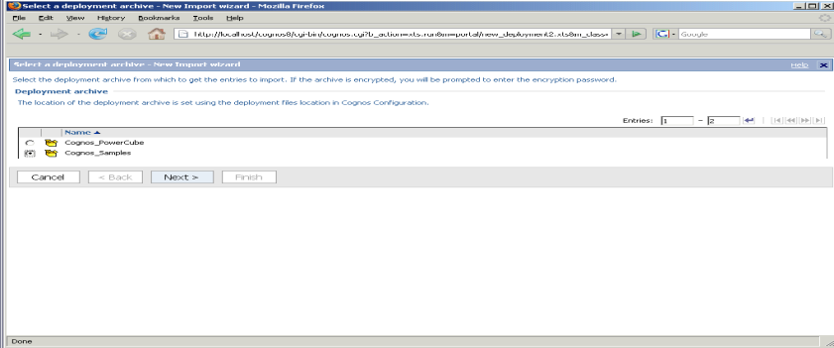
7. On the Specify name and descriptions page, click Next.

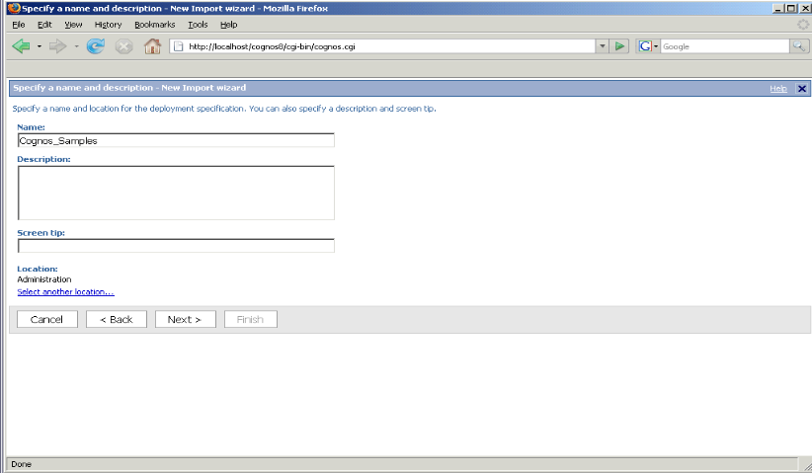
8. On the Select the public folders content page, click GO Data Warehouse, GO Sales, GO Sales and Retailers, and Query Studio Templates.
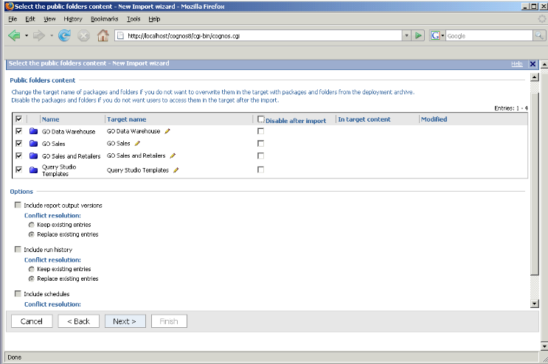
9. Clear the Disable after import check box beside all of the folders selected, and then click Next.
10. On the Specify the general options page, click Next.
11. On the Review the summary page, click Next.
12. On the Select an action page, click Save and run once, and then click Finish.
13. On the Run with options page, ensure Now is selected , click Run, and then click OK.
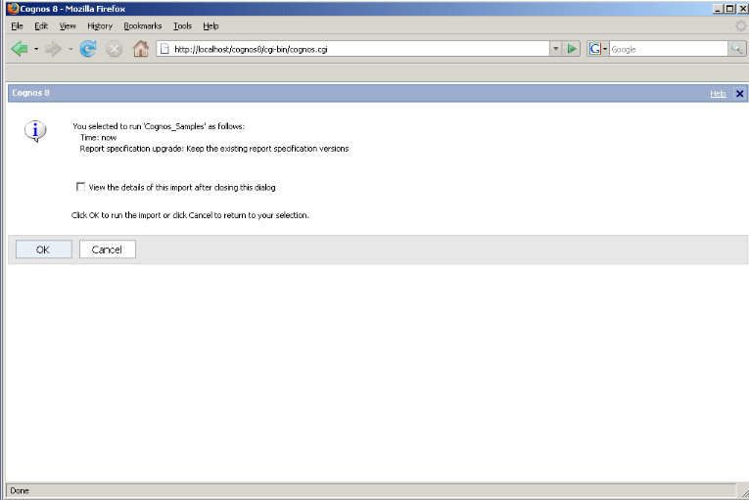
14. Repeat steps 4 to 12, selecting Cognos_PowerCube archive for import, and Great Outdoors Company on the Select the public folders content page.
15. Leave your browser open.

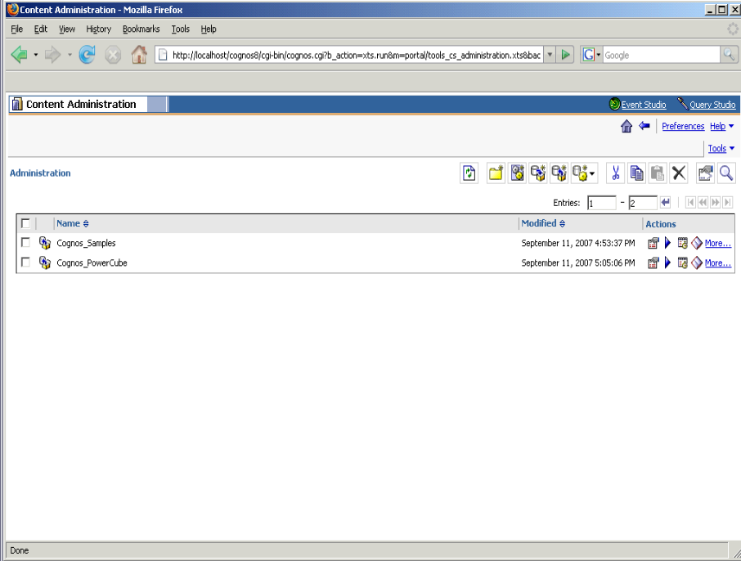

Lab 09 - Set Permissions in Cognos Connections

Task 1. Restrict Access to Administrative Tools.
1. In Cognos Connection, from the Tools menu, click Directory.
The Directory page shows two namespaces, Cognos and Local NT.
2. Under the Name column, click Cognos, click Next Page, and then beside the System Administrators role, click Set properties.
3. On the Set properties – System Administrators page, click the Members tab.
4. Click Add, select the Show users in the list check box, and then click Local NT.
5. Select the Admin Person (admin) check box, click Add (green arrow), and then click OK.
6. Select the Everyone check box, click Remove, and then click OK.
7. Leave Cognos Connection open.

Task 2. Add Specific Users to the Authors User Group.
1. In Cognos Connection from the Tools menu, click Directory.
The Directory page shows two namespaces, Cognos and Local NT.
2. Under the Name column, click Cognos, and then beside the Authors role, click Set properties.
3. On the Set properties – Authors page, click the Members tab.
4. Click Add, select the Show users in the list check box, and then click Local NT.
5. Click Next Page, select the Frank Bretton (brettonf) check box, and then click Add (green arrow).
6. Click Next Page until you see Jörg Kunze, select the Jörg Kunze (kunzej) check box, and then click Add (green arrow).
7. Click Next Page until you see Kazumi Uragome, select the Kazumi Uragome (uragomek) check box, and then click Add (green arrow).
8. Click OK.
9. Select the Everyone check box, click Remove, and then click OK.
10. Beside Analysis Users, click Set Properties.
11. Click the Members tab, select the Everyone check box, and then click Remove.
12. Click OK.
13. Repeat steps 10 – 12 to remove Everyone from the following groups:
• Consumers
• Controller Users
• Data Manager Authors
• Metrics Authors
• Metrics Users
• Planning Users
• Query Users
14. Close Cognos Connection.

Lab 10 - Tune Server Performance

Task 1. Set Maximum Execution Time.
Steps
- Start Cognos Connection.
- In the upper-right corner, click Launch, Cognos Administration.
- On the Status tab, click System.
- In the upper-left corner of the Scorecard pane, click the arrow to view the Change view menu. Click Services and the service you want.
Tip: You can also change the queue time limit settings at the dispatcher or service level.
- Click the arrow for the Actions menu next to the service and click Set properties.
Tip: You can also set these service settings at the System level.
- Click the Settings tab.
- Select Tuning from the Category list.
- In the Value column, type a new value for the Maximum execution time for the <service_name> (seconds) setting.
- Click OK.

Task 2. Set Usage Peak Periods.
Steps
- Start Cognos Connection.
- In the upper-right corner, click Launch, Cognos Administration.
- On the Status tab, click System.
- In the upper-left corner of the Scorecard pane, click the arrow to view the Change view menu. Click All dispatchers.
- Click the arrow for the Actions menu next to the dispatcher and click Set properties.
- Click the Settings tab.
- Select Tuning from the Category list.
- In the Value column, type new values for the following settings:
  - Peak period start hour
  - Non Peak period start hour
Tip: If you want to reset a configuration setting to its default value, select its check box and click Reset to default value.
- Click OK.

